
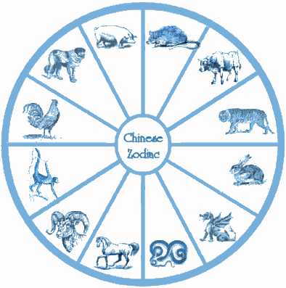
Year 1 Computing
Chinese New Year Programming Project
2022 is the year of the Tiger, 2021 is the year of the Ox, 2020 was the year of the Rat, 2019 was the year of the Pig (aka Boar), 2018 was the year of the Dog. 2017 was the year of the Rooster etc. (see table on the right). The Chinese years occur in a cycle of 12. Your program will ask a person to enter their date of birth and it will then tell them whether they are a Rat, Ox, Tiger, Rabbit, Dragon, Snake, Horse, Goat, Monkey, Rooster, Dog, or Pig.
Hint – use the if … { } or – switch … {case …} statements
– see Chapter 3 of the C# course.
switch (dobYear) {
case 1996: animal = “Rat”; break;
case 1997: animal = “Ox”; break;
case 1998: animal = “Tiger”; break;
case 1999: animal = “Rabbit”; break;
case 2000: animal = “Dragon”; break;
case 2001: animal = “Snake”; break;
case 2002: animal = “Horse”; break;
case 2003: animal = “Goat”; break;
case 2004: animal = “Monkey”; break;
case 2005: animal = “Rooster”; break;
case 2006: animal = “Dog”; break;
case 2007: animal = “Pig”; break;
}
Extension 1
The year 1900, 1912, 1924 etc, were also the year of the Rat – change your case statement to reflect this and allow the person to enter their date of birth in the format: 12/01/2000 (meaning 12th January 2000). Divide this up into day, month, and year.
Hint – look up string manipulation in C# Chapter 7
Console.Writeline(“What is your birthdate?” ); Console.Writeline (“dd/mm/yyyy ?: “);
String dob = Console.Readline();
int dobYear = Convert.ToInt32(dob.Substring(6,4));
// dobYear is the birth year as an integer


modYear :=( dobYear – 1900) % 12

Hint – Use % 12 on the variable “year” for the remainder
If modYear = 0 then animal = “Rat”
i.e. 2000 – 1900 = 100; 100 mod 12 = 4
if modYear = 4 then animal = “???”
Extension 2
Add validation to make sure people enter their date of birth in a reasonable range. Make this a procedure or function and have range checks on the day, the month and the year, which are returned to the main program.
Hint – look up Subprocedures Functions and parameters in C# Chapter 6, then validation in C# Chapter 8
Extension 3
By careful analysis you can also tell them their western astrological sign: Aries: March 21 - April 19, Taurus: April 20 - May 20, Gemini: May 21 - June 20, Cancer: June 21 - July 22, Leo: July 23 - Aug 22, Virgo: Aug 23 - Sept 22, Libra: Sept 23 - Oct 22, Scorpio: Oct 23 - Nov 21, Sagittarius: Nov 22 - Dec 21, Capricorn: Dec 22 - Jan 19, Aquarius: Jan 20 - Feb 18, Pisces: Feb 19 - Mar 20.
Extension 4
The Chinese year does not start on January 1st. It starts on the lunar New Year, which is the second new moon after the winter solstice. This is always on December 21st, the second new moon of the new year is February 12th in 2021, this is the actual start of the Chinese New Year, the year of the Ox. The Chinese have been calculating the New Year for a long time, and 2021 will be lunar year 4720 in the Chinese calendar system.
Get your program to work for any year!

